Table of contents
Introduction 2
Physical Features 2
Orbit and Spin 2
Phases and Eclipses 2
Observation and Exploration 2
10 facts about the MOON 3

Introduction
The Moon is a large natural object that orbits, or travels around, Earth. After the Sun it is the brightest object in the sky.
The average distance between the Moon and Earth is about 384 400 kilometres. Compared to the distance between the other planets and Earth, this distance is small. In fact, the Moon is close enough to affect the level of seas on Earth. Every day the seas seem to rise and fall. This is because of a force called gravity. The Moon's gravity pulls on Earth. It is too weak to affect the whole planet, but it does make the water move. This creates tides.

Physical Features
The Moon is slightly more than one quarter the size of Earth. Its diameter, or distance through its centre, is about 3 500 kilometres.
The Moon is made mostly of rock. The surface has thousands of pits called craters. The craters form when chunks of rock and metal called meteorites crash into the Moon. These crashes have covered the Moon's surface with rocks and dust. The Moon also has plains made of lava that erupted from volcanoes billions of years ago.
During the daytime, when the Moon faces the Sun, its surface temperature averages about 107°C. However, at night the temperature drops to about −153°C.

Orbit and Spin
Like the planets, the Moon has two types of movement: orbit and spin. The Moon orbits, or travels around, Earth. It takes the Moon about 27 days to make one trip around Earth. The Moon also spins about its centre. It completes one rotation in about 27 days - the same time it takes to complete one orbit. For this reason, the same side of the Moon always faces Earth.

Phases and Eclipses
When viewed from Earth, the Moon looks different at different times. These varying appearances are called phases. Sometimes the Moon looks like a full circle. At other times it appears as only a thin slice or looks completely dark. However, the Moon's shape does not change - it just looks that way from Earth. The Moon reflects light from the Sun. As the Moon orbits Earth, the Sun shines on different parts of the Moon. This causes different parts to be visible from Earth.
Sometimes the way the Moon, the Sun and Earth are positioned causes an event called an eclipse. During an eclipse of the Sun, the Moon blocks the view of the Sun for a short time. During an eclipse of the Moon, Earth prevents the Sun from shining on the Moon.

Observation and Exploration
People have observed the Moon since ancient times. In the 1600s the invention of the telescope allowed people to study the Moon more closely.
Even greater advances in knowledge have come from the many spacecraft sent to the Moon since 1959. In 1966 Luna 9, a spacecraft from the Soviet Union, became the first unmanned craft to successfully land on the Moon. In 1969 the U.S. Apollo 11 craft carried the first people—Neil Armstrong and Edwin (Buzz) Aldrin Jr. — to walk on the Moon. Ten other astronauts have walked on the Moon since then.

10 facts about the Moon
- The Moon is a dusty ball of rock, measuring 3 476km in diameter – that's roughly a quarter of the size of Earth.
- Its surface is home to mountains, huge craters and flat planes called 'seas' made of hardened lava.
- The Moon is Earth's only natural satellite – a celestial body that orbits a planet. Its orbit around our planet is shaped like a slightly squashed circle known as an ellipse.
- It takes 27.3 days for the Moon to travel all the way around the Earth and complete its orbit.
- Although the Moon shines bright in the night sky, it doesn't produce its own light. We see the Moon because it reflects light from the Sun.
- Ever noticed how the Moon appears to change shape each night? That's because as the Moon orbits the Earth, the Sun lights up different parts of its surface – so it's just our view of the Moon that's changing, not the Moon itself.
- As the Moon travels, it rotates on its own axis, just like our planet. It takes roughly the same amount of time for the Moon to make a full rotation as it does for it to complete its orbit. This means we only ever see around 60% of the Moon's surface from Earth! The part that faces Earth is known as the 'near side' and the other, the 'far side'.
- The temperature on the Moon varies from super-hot to super cold! When the Sun hits its surface, temperatures can reach a scorching 127°C. But when the Sun 'goes down', temperatures can plummet to around -153°C. Brr…
- Like Earth, the Moon has gravity (the force that pulls things towards the ground). But the Moon's gravity is weaker, only one sixth of the Earth's gravity, in fact. That means you'd weigh much less if you were to stand on the Moon!
- Scientists aren't entirely sure how the Moon formed. A popular theory is that a Mars-sized rock, named Theia, crashed into Earth around 4.5 billion years ago. The debris from the collision clumped together to make what is now … Our Moon!
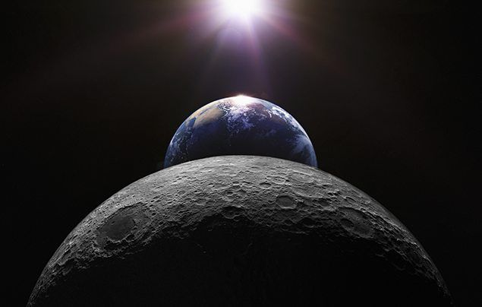
Question/Vraag 2.4

Moon Phases for 2024
New Moon September 3, Tue 03:56 September 3, Tue
First Quarter September 11, Wed 08:06 September 11, Wed
Full Moon September 18, Wed 04:36 September 18, Wed
Last Quarter September 24, Tue 20:52 September 24, Tue
New Moon October 2, Wed 20:50 October 2, Wed
First Quarter October 10, Thu 20:56 October 10, Thu
Full Moon October 17, Thu 13:27 October 17, Thu
Last Quarter October 24, Thu 10:05 October 24, Thu
New Moon November 1, Fri 14:48 November 1, Fri
First Quarter November 9, Sat 07:56 November 9, Sat
Full Moon November 15, Fri 23:29 November 15, Fri
Last Quarter November 23, Sat 03:29 November 23, Sat
New Moon December 1, Sun 08:22 December 1, Sun
First Quarter December 8, Sun 17:27 December 8, Sun
Full Moon December 15, Sun 11:02 December 15, Sun
Last Quarter December 23, Mon 00:19 December 22, Sun
New Moon December 31, Tue 00:27 December 30, Mon

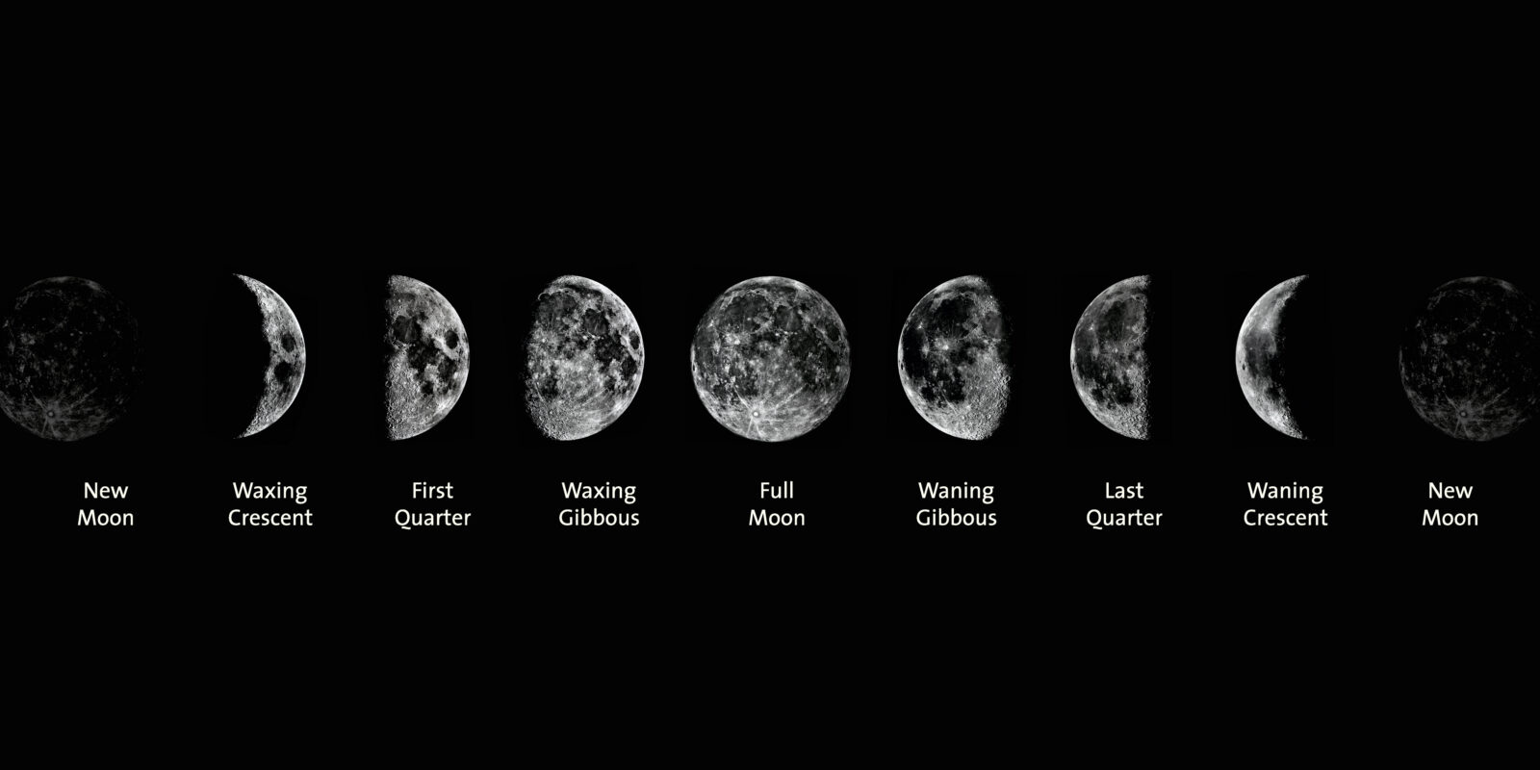
Phases of the Moon

